# Technical Note: Supervised Machine Learning Techniques

Puja Kawale, Software Engineering, San Jose State University, Santa Clara, USA., Dt.11/15/2018, SJSU ID: 012506156, puja.kawale@sjsu.edu

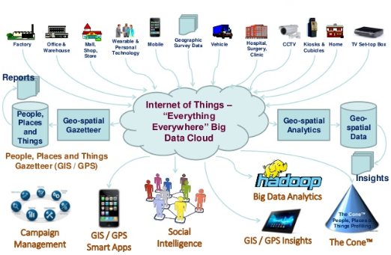

Figure: Internet of Things Sources and uses:

The Internet of Things involves SPEED!

Speed of all smart IOT device sensors capturing and passing data ultimately reduced latency for the customer to achieve satisfaction level are main leads to smooth and secure transactions. The imminent speeds of 5G technology are expected to abet this demand.

Below tabulated data belongs to all those data collectors that are part of the enormous IOT in today’s date. –

Please open the excel:



References

<http://xmpro.com/7-types-industrial-iot-data-sources/>

<https://core.ac.uk/download/pdf/51065422.pdf>

<https://www.w3.org/TR/motion-sensors/>

<https://techtutorialsx.com/2018/04/20/esp32-arduino-dht22-minimum-sampling-period/>

<https://www.pmel.noaa.gov/ocs/sensors>

<https://www.pmel.noaa.gov/ocs/sampling-rates>

<https://www.researchgate.net/profile/Ahmed_Al->

<https://www.researchgate.net/profile/Ahmed_Al-Haiqi/publication/256618651_On_the_Best_Sensor_for_Keystrokes_Inference_Attack_on_Android/links/00b495238198d3ea62000000/On-the-Best-Sensor-for-Keystrokes-Inference-Attack-on-Android.pdf>

<https://www.researchgate.net/figure/Time-overhead-for-different-sensors-at-different-sampling-rate-and-under-different_tbl1_318011372>

<https://en.wikipedia.org/wiki/FasTrak>

<http://support.belladati.com/display/IOT/BellaDati+IoT+Data+Collector?lang=ja>